HLD GUIDELINES



Table of Contents
1 Introduction 1
1.1 Purpose 1
1.2 Overview 1
1.3 Scope 1
1.4 Definitions, Acronyms and Abbreviations 1
1.4.1 Definitions: 1
1.4.2 Acronyms: 1
1.4.3 Abbreviations: 1
1.5 References 2
2 Product Architecture 3
2.1 Architecture Diagram 3
2.2 Alternatives 3
3 System Design 4
3.1 <Sub System Name> 4
4 Logical Data Model 5
5 Integration Interface Design 5
6 User Interface Design 5
6.1 Human Interface 5
7 Deployment View 6
8 Performance Goals 7
9 Design Constraints 7
10 Traceability 7
11 Appendix 7
11.1 Packaging and Installation considerations 7
11.2 Supplementary Information 7

Introduction
The High Level Design Document (HLDD) depicts the high level design of software requirements gathered for the system.

High Level Design Document contains the design of the system to a level of detail sufficient to enable designers to design a system in detail to satisfy the requirements.

High-level design of the system is depicted in the form of Architecture, Class diagrams, E-R model and User interface.

The following sections provide overview of the entire design document.

Purpose
This subsection
- Clearly defines the purpose of HLD
- Specifies the intended audience for the HLD

Overview
Provide overview of the system. Describe what the rest of this document contains and how it is organized.

Scope
The scope of the High Level Design is presented.

Definitions, Acronyms and Abbreviations
This section provides definitions of all terms, acronyms and abbreviations required to properly interpret the design document. This information may be provided by reference to one or more Appendices in the design document.

Definitions:

Term | Definition

Acronyms:

Acronym | Meaning

Abbreviations:

Abbreviation | Expansion

References
Provides a complete list of documents referenced elsewhere in the design document. Identifies each document by title, report number (if applicable), date and source

S. No. | Title | Date | Source

Product Architecture
This section provides description of the system architecture, highlighting the major responsibilities the system must undertake.

The architecture should decompose the system into layers and subsystems. It should describe the overall structure of the implementation model that provides a foundation for more detailed design work.

The architecture provided in this section should support the interfaces mentioned and also take into consideration the supplementary requirements such as Security, Performance, Usability, Reliability, Supportability, and Scalability.

Architecture Diagram
This sub section provides a pictorial representation of the architecture.

Alternatives
[Optional]
This sub section discusses other architectural styles considered. Rationale behind selection of the style presented in Section 2.1 is provided.

System Design
This section describes the method or approach used for the system design. If one or more formal/published methods are adopted or adapted, include a reference to a more detailed description of these methods.

In this section, core (Architecturally significant) classes of the system, operations, attributes and relationship among various classes are identified for the architecturally significant / High level Use Cases from Requirement document. Package diagram showing dependencies among packages can be provided. Provide a description on how the software interfaces captured for the system would be realised.

Section 3.1 is repeated for each sub system. If the system is not considered as sub systems, the entire system can be addressed in section 3.1.

<Sub System Name>
This sub section provides detailed description of the sub system. Use case analysis model (identifying entity, boundary and control classes) is applied. Mention the software interfaces that are addressed in each sub system. Also consider the supplementary specifications Security, Performance, Usability, Reliability, Supportability, Scalability while identifying the significant classes.

Numbering the Use Case Class View:
Class View for each use case of the sub system is labelled with prefix UC-CV followed by the number starting with ‘1’ (one) for the first use case of the sub system. Numbering of the use case class view should be continued in each sub systems and should not start afresh for each sub system.

Example: -
UC1-CV1 – label for the first use case class view.
UC5-CV2 – label for the class view of fifth use case.
UC1-CV1 <Use Case Name> Class View
Provide the class diagram. List the classes in the use case with interface description, processing details and any references that provide additional information in understanding the class.

Logical Data Model
This section addresses the conceptual and logical views. Data model created as part of the application is described in the form of E-R diagram. While arriving at the data model, consider the information provided in “Logical Data Model” section of Requirement.

Numbering the Logical Data Model:
If the logical data model is depicted as sub data models, each sub model is labelled with prefix SDM followed by the number starting with ‘1’ (one) for the first data model.

Example: -
SDM1 – label for the first data model.
SDM2 – label for the second data model.

SDM1 <Data Model Name>
Data model created as part of the application is described in the form of E-R diagram.

Integration Interface Design
This section describes the integration interfaces exposed in the product to communicate with various other external applications. Describe the high level Integration use cases, integration technology used etc.

User Interface Design
Provide a high level abstraction of the user interface that describes the flow in the system. Consider the information provided in “User Interfaces Screens” section of Requirement Document. Provide the purpose of each screen identified in the application as per the workflow.

Numbering the User Interface Design:
Each screen identified is labeled with prefix UID followed by the number starting with ‘1’ (one) for the first screen.

Example: -
UID1 – label for the first screen.

UID1 < Screen Name >
Description: <Describe the purpose of the screen in brief and the activities carried out>.

Human Interface
[Optional]
An overview of any human interfaces to be designed for the system is presented.
For ex: - Provision for accessibility.

Deployment View
This section describes information about where and how the system is deployed and explains diagrammatically the physical network (hardware) configurations on which the software is deployed and run. At a minimum for each configuration it should indicate the physical nodes (computers, CPUs) that execute the software, and their interconnections (bus, LAN, point-to-point, and so on.)

The Deployment Model is typically depicted in a diagram such as the one shown below:
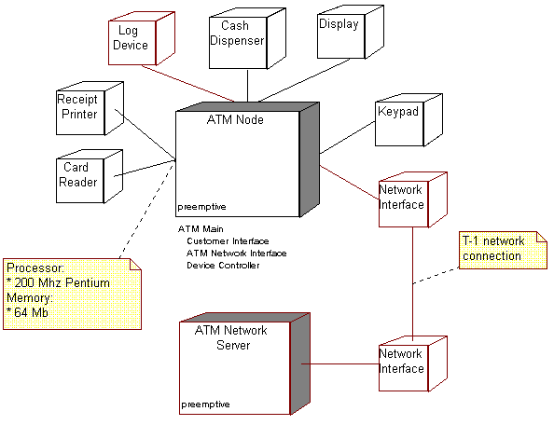

Performance Goals
Describe the expected performance of your product in terms of response time, CPU usage and Net work bandwidth usage at various layers of your application.

Design Constraints
Any special design constraints that will impact the manner in which the system is to be designed, implemented or tested are noted here.

Traceability
Provide the details of the requirements from which the HLD is derived from

Requirement Document

Appendix
Presents information that supplements the design specification.

Packaging and Installation considerations
Special considerations for software packaging and installation are presented.

Supplementary Information
Provide any supplementary information.

